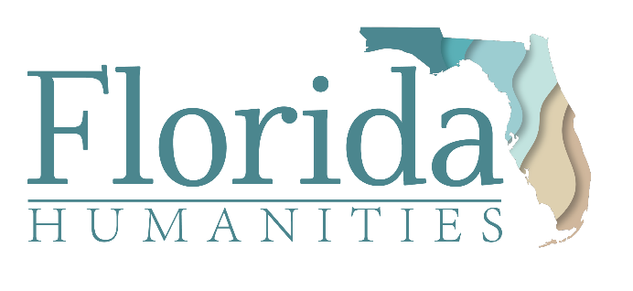

FOR IMMEDIATE RELEASE
Contacts:
Your Name, Your Title, Your Organization
Phone: XXX-XXX-XXXX | Cell: XXX-XXX-XXXX
Email: xxxxxx@xxxx.com
Lashonda Curry, Communications Director, Florida Humanities
Phone: 727-873-2011 | Cell: 813-447-1752
Email: lcurry@flahum.org

[Your Organization Name] Receives
Florida Humanities “American Rescue Plan”
COVID Relief Funding
YOUR CITY NAME HERE, Florida (November X, 2021) — Florida Humanities, the statewide, nonprofit affiliate of the National Endowment for the Humanities (NEH), has awarded [your organization name] a $[award amount] grant for general operating costs to help recover from the economic impact of the COVID-19 pandemic.
[Include one to two sentences here about how the ARP grant will be used to support your organization. This section could also include the ways COVID financially impacted your organization.]
[“Quote from someone in your organization explaining what it means for the organization to receive the ARP funding. Quote could also include how this funding will support your role in the community or impact the people you serve, etc.”]
The NEH received $135 million from the American Rescue Plan (ARP) Act of 2021, which was approved by Congress this past spring. The state humanities councils, including Florida Humanities, each received a portion of the NEH award to support museums, archives, historic sites and other humanities-focused nonprofits. [your organization name] was one of 129 organizations in Florida that was awarded ARP funding totaling $1.88 million from Florida Humanities. The grants are intended to meet immediate operational needs in order for organizations to remain viable and maintain delivery of public humanities programming and resources in their communities. Florida Humanities received 188 applications for ARP funding, with nonprofits requesting the most funds for staffing and utilities.
These funds, said Florida Humanities Executive Director Dr. Nashid Madyun, provide a safety net for the organizations so they can focus on other priorities, such as fundraising and creating programming. “For smaller nonprofits, when bills are paid and staff are safe and intact, that type of alleviation is immeasurable,” he said. “Florida Humanities is honored to provide a lifeline to our state’s cultural and historic organizations, ensuring they continue to enrich their local communities, and the Sunshine State at large, for years to come.”

Funding for this grant was provided by Florida Humanities with funds from the National Endowment for the Humanities (NEH) as part of the American Rescue Plan (ARP) and NEH’s Sustaining the Humanities through the American Rescue Plan (SHARP) initiative. Any views, findings, conclusions or recommendations expressed in this announcement do not necessarily represent those of Florida Humanities or the National Endowment for the Humanities.
______________________________________________________________________

About [Your organization name]

[Your organization’s boiler plate/summary of who you are and what you do.]

About Florida Humanities
Florida Humanities, the statewide, nonprofit affiliate of the National Endowment for the Humanities, is dedicated to preserving, promoting, and sharing the history, literature, culture, and personal stories that offer Floridians a better understanding of themselves, their communities, and their state. Since 1973, Florida Humanities has awarded more than $16 million in support of statewide cultural resources and public programs strongly rooted in the humanities. These programs preserve Florida’s diverse history and heritage, promote civic engagement and community dialogue, and provide opportunities to reflect on the future of Florida. Learn more at www.FloridaHumanities.org.

###

